AYOMIDE ASSIGNMENT (GENERATIVE AI ECOSYSTEM)
1. HUGGING FACE
After creating the account, i chose an image generation space, Firered Image Edit which i edited some images with my prompts and the model prompt to test the difference.
Deliverable

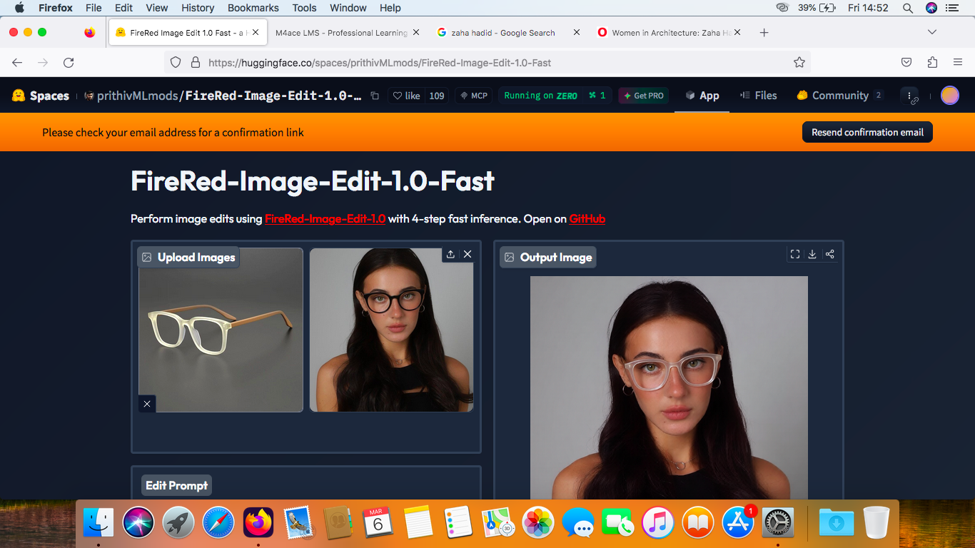
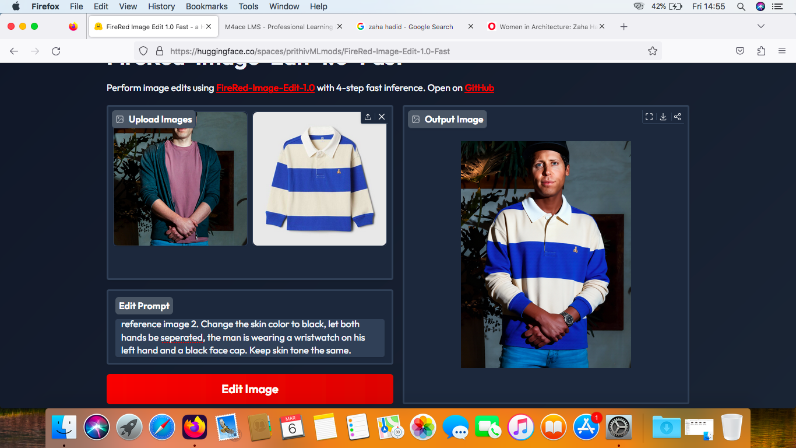
Second Result
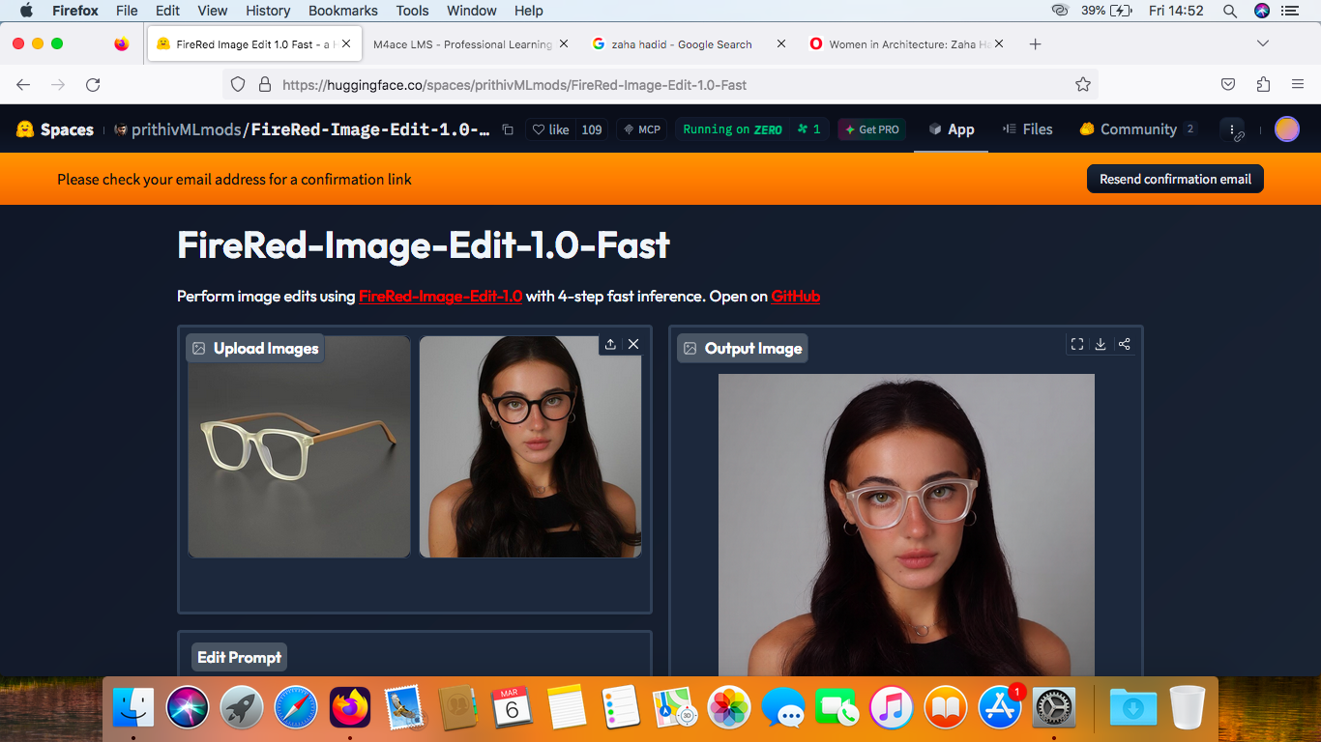
Part 2. Kaggle
After creating my account, i viewed some dataset of my interest and i selected one.
https://www.kaggle.com/datasets/umerhaddii/world-news-reddit-data-global-event-discussions
A large dataset helps train AI by ensuring more accurate search results and to balance information by identiying similarities and differences accross sources hence limiting false information.

Part 3. Google Colab
Deliverables
My custom prompt
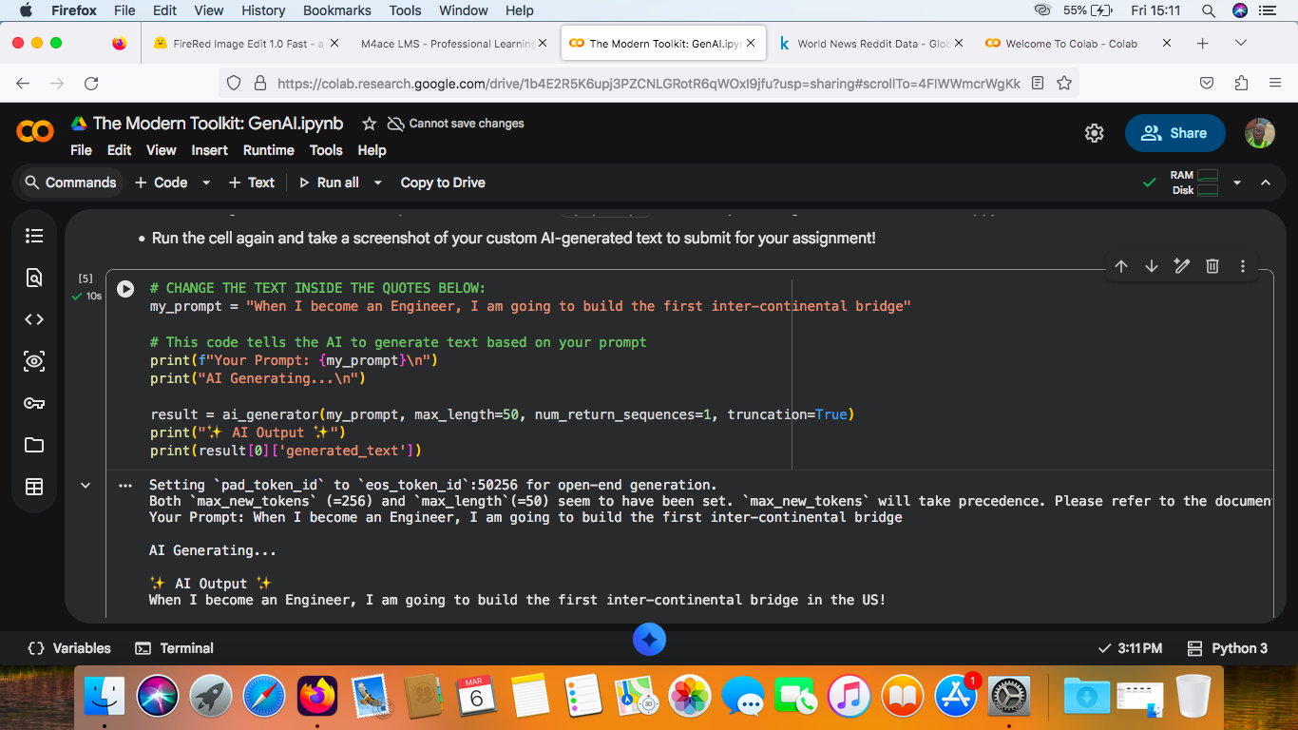
Generated output
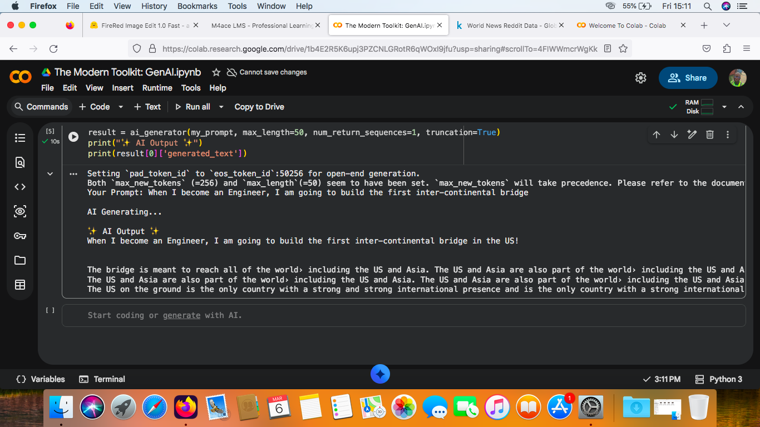
Part 4. Github
Deliverable
https://github.com/ArinadAyo/Ayomide-Olaleye-M4ACE-ML-AI

